Practical 11
Aim : Study and apply real life application of Blockchain.

Introduction
Blockchain is a distributed digital ledger that records transactions in a secure and transparent manner. Instead of storing transaction records on a single centralized server, copies of the ledger are maintained by multiple participants in the network.
A transaction is grouped with other transactions into a block. After verification, the block is added to the blockchain. Once recorded, the transaction is extremely difficult to alter.

Real-Life Application: Cryptocurrency Transaction
A common real-life application of blockchain is cryptocurrency transactions, such as transferring cryptocurrency from one user to another.
For example:
User A → User B: 0.5 ETH
The transaction follows these steps:
- Transaction Creation
User A enters User B's wallet address and the amount to transfer.
- Digital Signature
User A digitally signs the transaction using their private key.
- Broadcasting
The transaction is broadcast to the blockchain network.
- Transaction Verification
Network participants verify the transaction and check whether User A has sufficient funds.
- Block Formation
The verified transaction is included in a new block.
- Consensus
The blockchain network reaches agreement on the validity and ordering of the block.
- Block Addition
The block is added to the blockchain.
- Transaction Completion
The balance of User A decreases and User B's balance increases.

Example
Suppose Divy wants to send 0.5 ETH to another person's wallet.
Divy
│
│ 0.5 ETH transaction
▼
Blockchain Network
│
│ Verification
▼
New Block
│
│ Added to Blockchain
▼
Recipient's Wallet
The transaction can then be viewed on the blockchain using the transaction hash.

Simple implementation using Python
import datetime

class Block:
def __init__(self, index, data, previous_hash):
self.index = index
self.timestamp = datetime.datetime.now()
self.data = data
self.previous_hash = previous_hash
self.hash = self.calculate_hash()

def calculate_hash(self):
text = str(self.index) + str(self.timestamp) + self.data + self.previous_hash

hash_value = 0
for ch in text:
hash_value = (hash_value * 31 + ord(ch)) % 1000000007

return str(hash_value)

block1 = Block(1, "BlockChain", "0")

block2 = Block(2, "Bitcoin", block1.hash)

print("Block 1")
print("Index :", block1.index)
print("Timestamp :", block1.timestamp)
print("Data :", block1.data)
print("Previous Hash :", block1.previous_hash)
print("Hash :", block1.hash)

print("\nBlock 2")
print("Index :", block2.index)
print("Timestamp :", block2.timestamp)
print("Data :", block2.data)
print("Previous Hash :", block2.previous_hash)
print("Hash :", block2.hash)

print("\nConnection:")
print("Block 2 Previous Hash == Block 1 Hash")
print(block2.previous_hash == block1.hash)

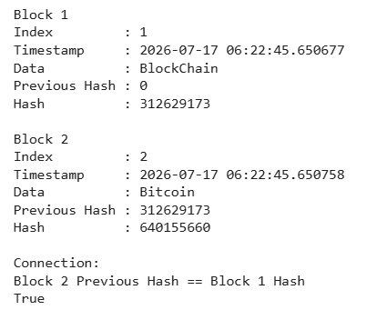

Advantages
- Transparency: Transactions can be publicly verified on public blockchains.
- Security: Cryptographic techniques protect transactions.
- Immutability: Confirmed records are difficult to modify.
- Decentralization: No single organization needs to maintain the entire ledger.
- Traceability: Transactions can be tracked using their blockchain records.
- Reduced intermediaries: Direct blockchain transactions can reduce dependence on traditional intermediaries.
Other Real-Life Applications
Blockchain-based transactions are also used or explored in:
Application | Use of Blockchain
Banking | Cross-border payments
Supply Chain | Tracking movement and ownership of goods
Real Estate | Recording property transactions
Healthcare | Secure sharing of medical records
Voting | Recording and verifying votes
Insurance | Automated claim processing
Digital Identity | Verification of identity
E-commerce | Secure digital payments

Theory (brief)
A private Ethereum network is a blockchain instance run independently of the public Ethereum mainnet or testnets, typically for local development and testing. It behaves like a real Ethereum network — supporting accounts, transactions, and smart contracts — but is fully controlled by whoever runs it, with no connection to outside miners or validators.
Smart contracts are self-executing programs deployed on the blockchain. Once deployed, their functions can be called externally to read or modify on-chain state, and the contract enforces its own rules on every call — including restricting certain actions to specific accounts.
Key concepts:
- Geth (Go-Ethereum) — an Ethereum client written in Go; running it in --dev mode spins up a private, single-node blockchain instantly, complete with a pre-funded developer account
- RPC endpoint — the HTTP interface (http://127.0.0.1:8545 by default) that Geth exposes, allowing external tools like Remix to send transactions and queries to the node
- Geth JavaScript console — an interactive console (geth attach) used to inspect the running node directly — checking network version, block number, and available accounts
- Owner-based access control — a common smart contract security pattern where the address that deployed the contract is stored as owner, and sensitive functions check msg.sender == owner before executing
- require() statement — a Solidity guard clause that reverts the transaction (undoing all state changes and refunding unused gas) if its condition is false, along with an optional error message
Tools used for this practical
- Go-Ethereum (Geth) — to create and run the private Ethereum network
- Command Prompt — to start Geth and attach the console
- Remix IDE (remix.ethereum.org) — to write, compile, and deploy the smart contract
- Web browser — to access Remix and interact with the deployed contract

Implementation
- Confirm Geth is installed correctly by running geth version in Command Prompt.
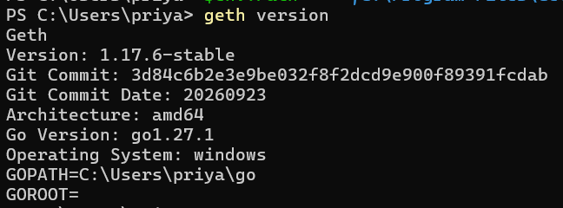
- Create a dedicated folder to hold the private network's data: mkdir C:\PrivateEthereum then cd C:\PrivateEthereum.
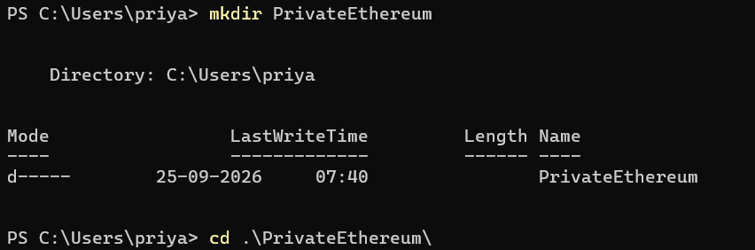
- Start the private network in developer mode: geth --datadir C:\PrivateEthereum --dev --http --http.api eth,web3,net --http.corsdomain "https://remix.ethereum.org". This launches a single-node Ethereum instance with a pre-funded developer account and keeps an HTTP RPC endpoint open for external tools to connect to.
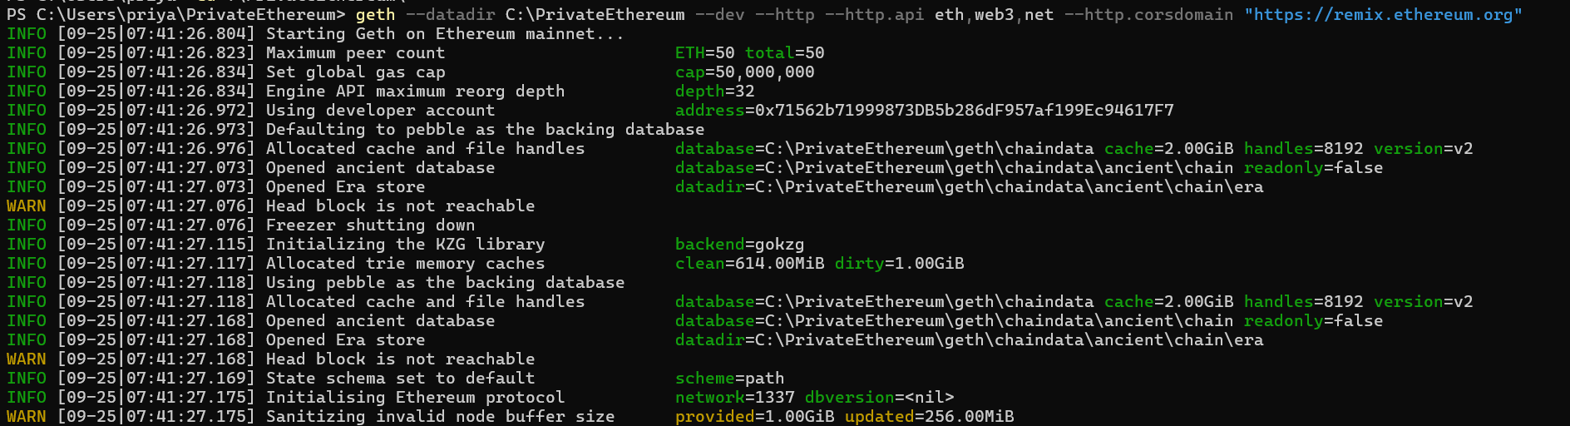
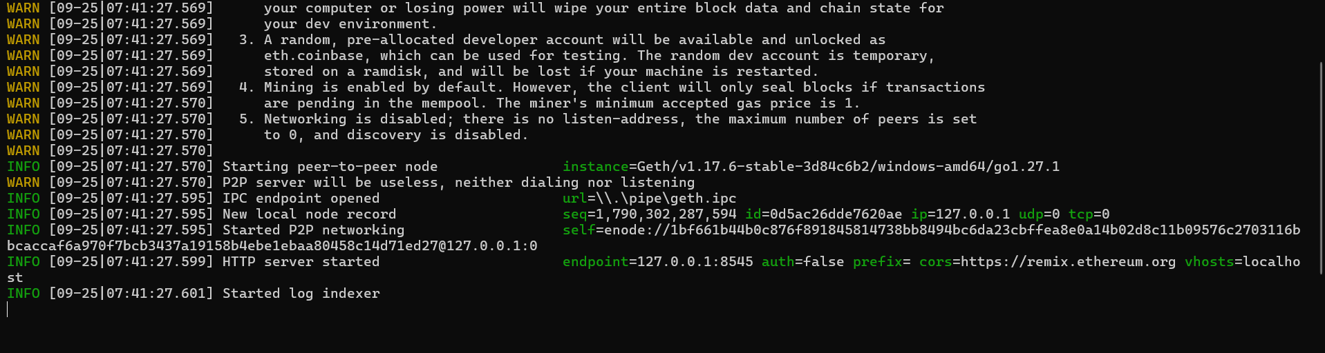
- In a separate Command Prompt window, attach to the running node's console: geth attach http://127.0.0.1:8545.
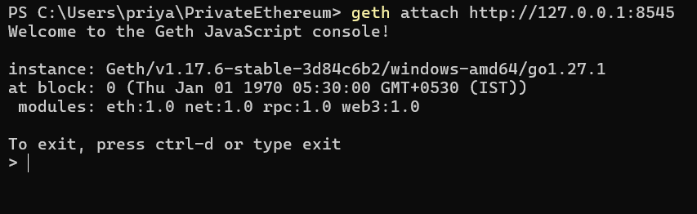
- From the console, verify the network is live and check its state: net.version (confirms the private chain ID), eth.blockNumber (current block height), and eth.accounts (lists the developer account created automatically).
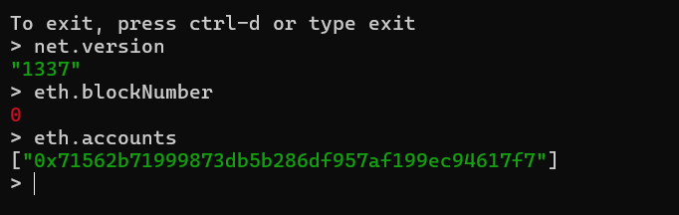
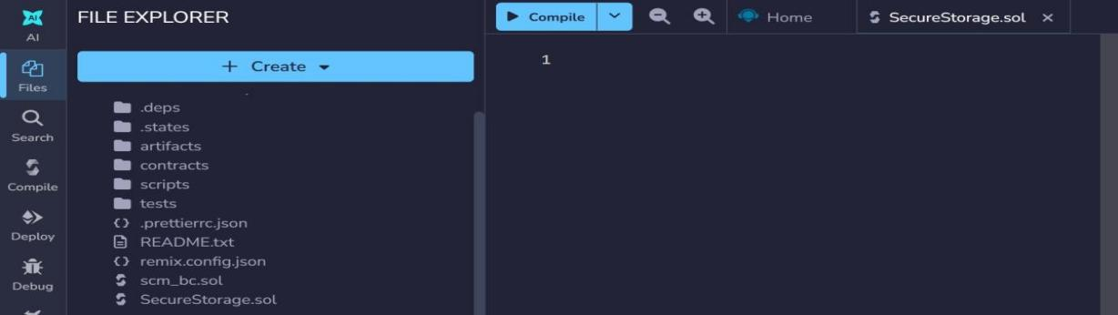
- Open Remix IDE in a browser and create a new file, SecureStorage.sol.
- Write the contract: it declares a public owner address set in the constructor to whoever deploys it, a public value variable, a setValue() function restricted to the owner via a require() check, and a getValue() view function open to anyone.
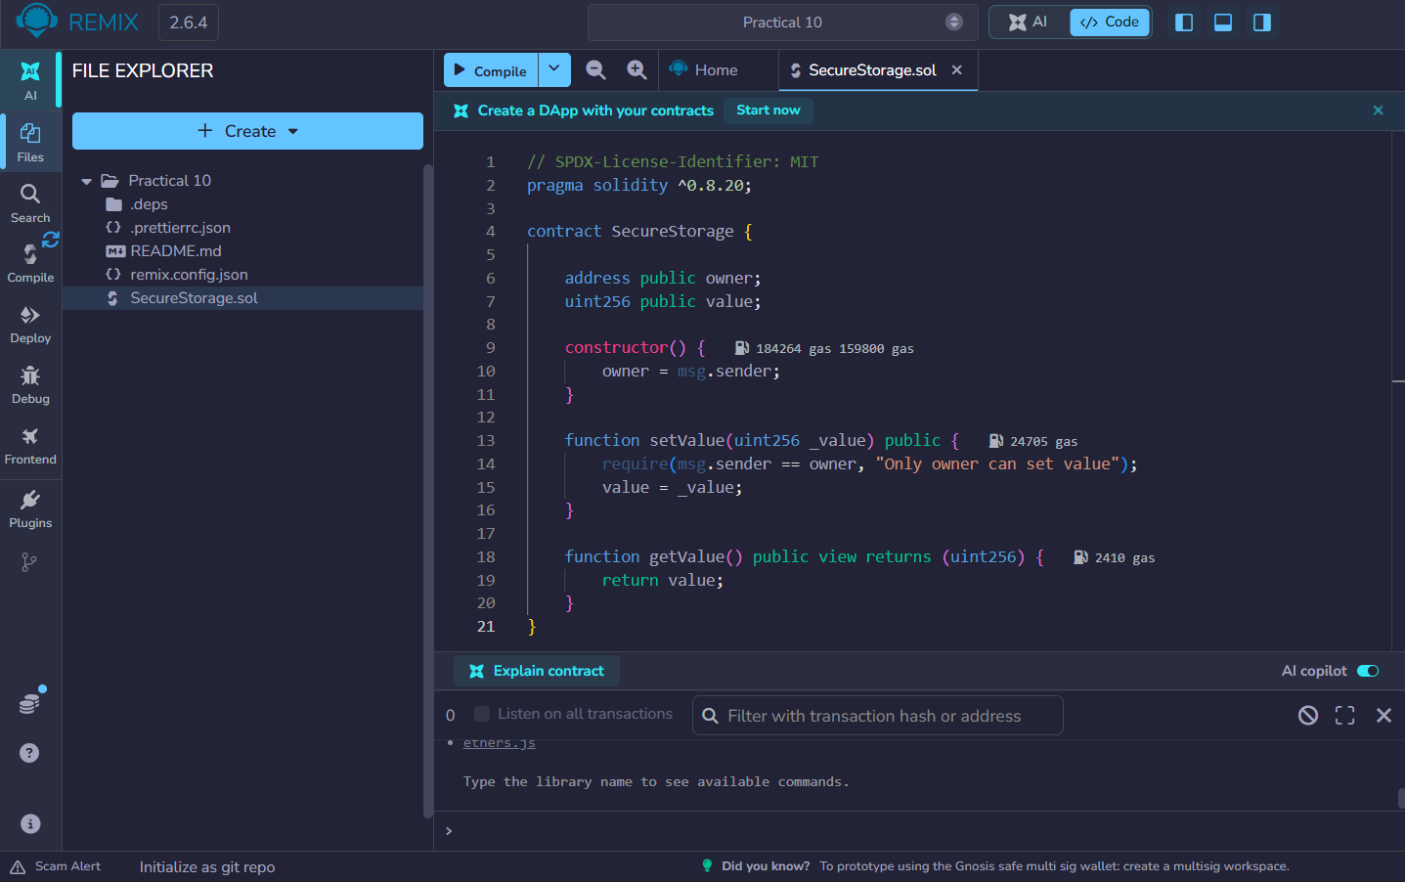
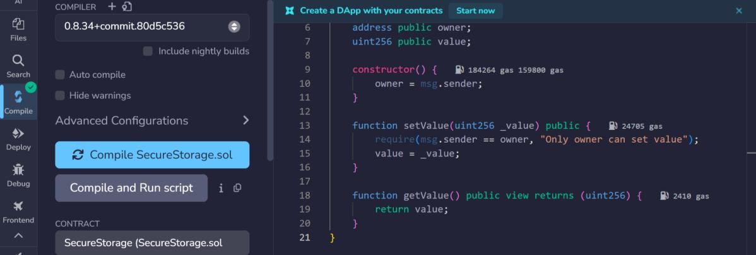
- Open the Solidity Compiler tab, select a compiler version matching pragma solidity ^0.8.20, and compile the contract.

- Go to Deploy & Run Transactions, and under Environment select "Custom - External Http Provider", pointing it to http://127.0.0.1:8545 so Remix connects to the private network instead of its default in-browser VM. The developer account from the private chain appears as the active account.

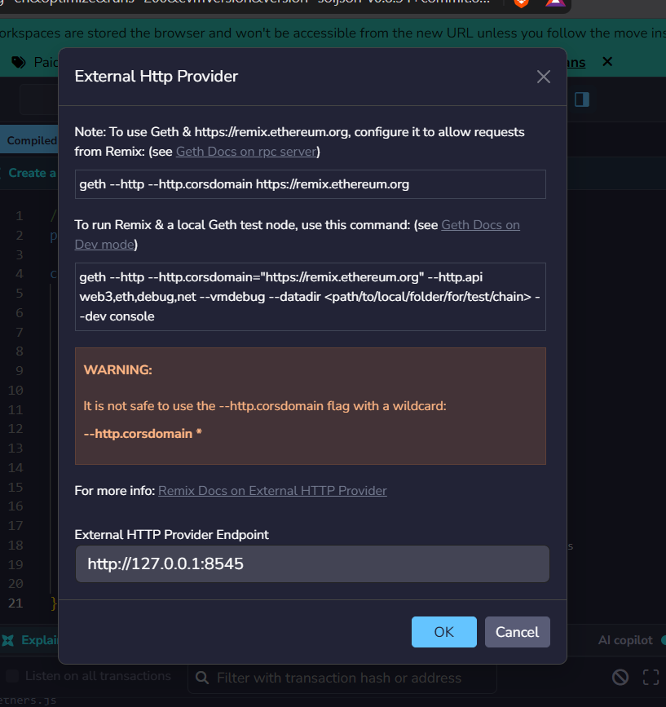
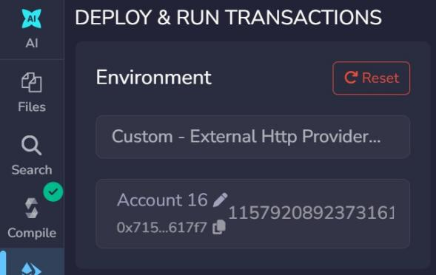
- Click Deploy; the contract is mined onto the private chain and appears under Deployed Contracts with its on-chain address.
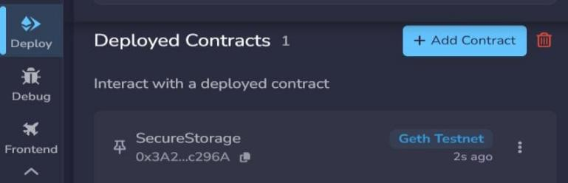


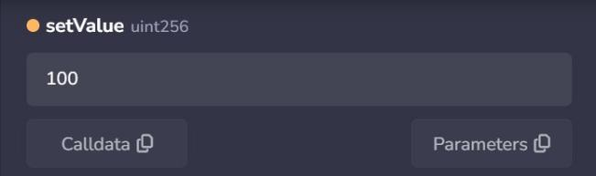
- Call setValue with a test number, then call getValue to confirm the stored value is correctly written to and read from the blockchain.

